**1. Program to Demonstrate Regular Expressions in Python**

**Aim:**  
To demonstrate the use of regular expressions in Python for matching and searching patterns in a given text.

**Algorithm:**

1. Import the re module in Python.
2. Define a text string.
3. Use re.search() to search for a specific pattern.
4. Use re.findall() to find all occurrences of a pattern.
5. Use re.match() to match the pattern at the beginning of the string.
6. Display the results.

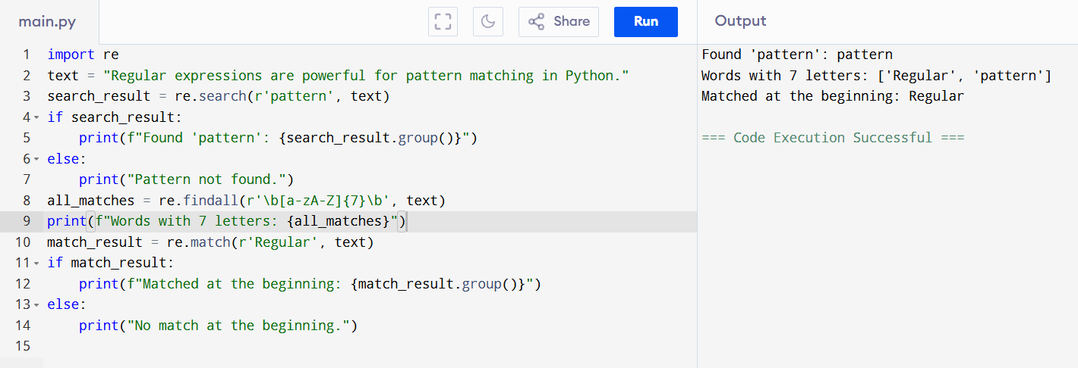

**Result:**  
The program demonstrates how to use regular expressions in Python for searching, finding, and matching patterns in text.